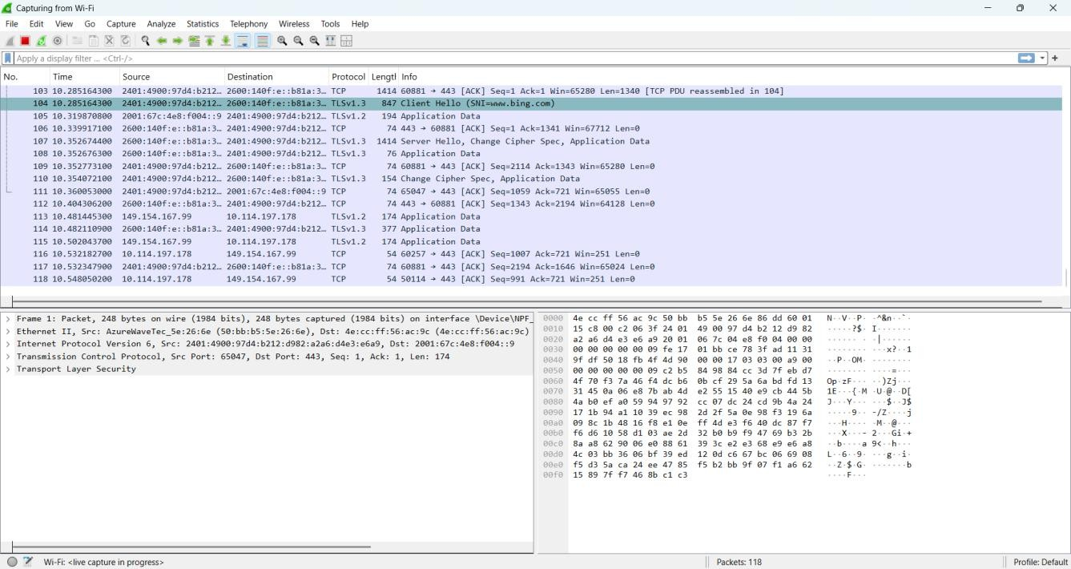
Step-1,2:

Step-3:

Skill-1

2520030413

TCP:
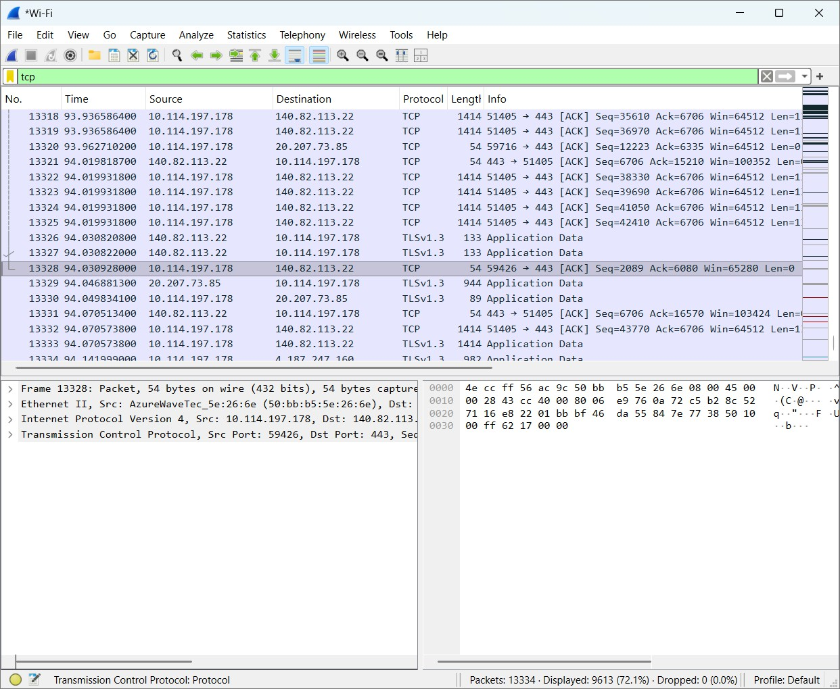

UDP:

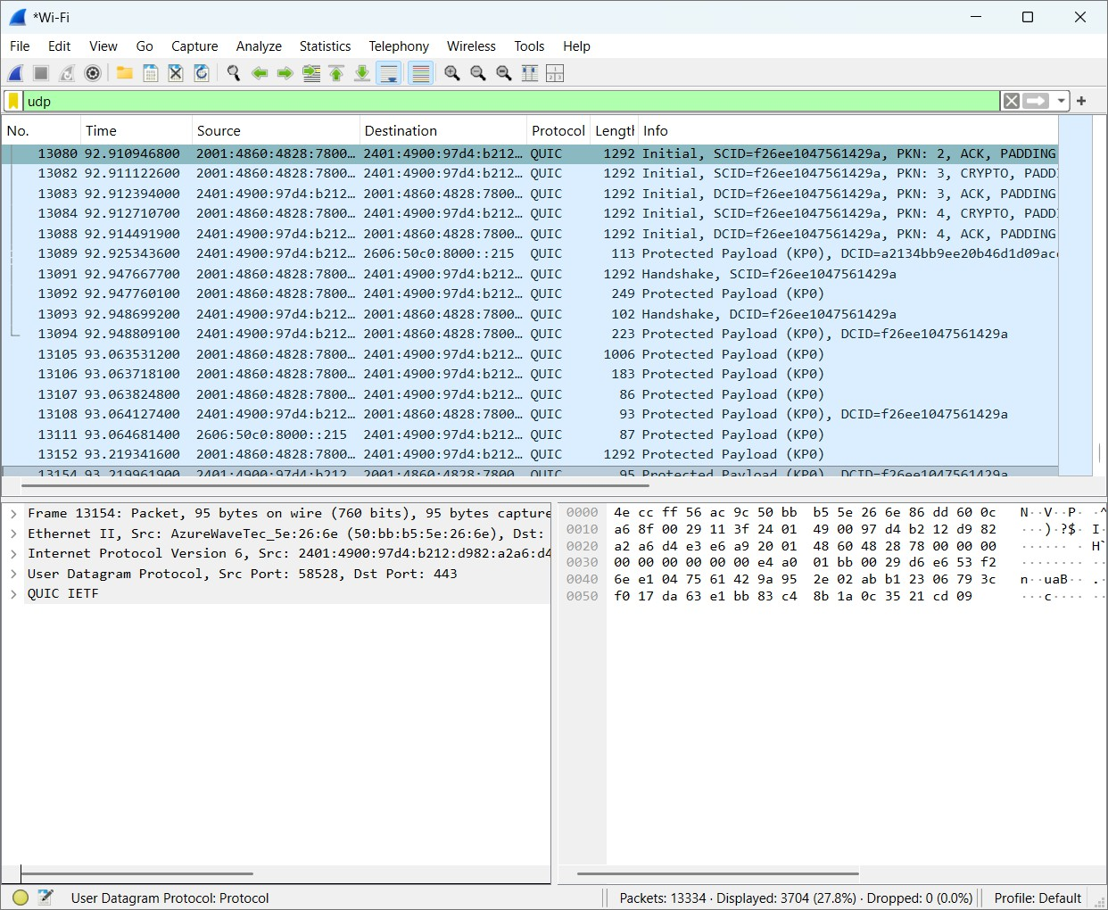

Frame:

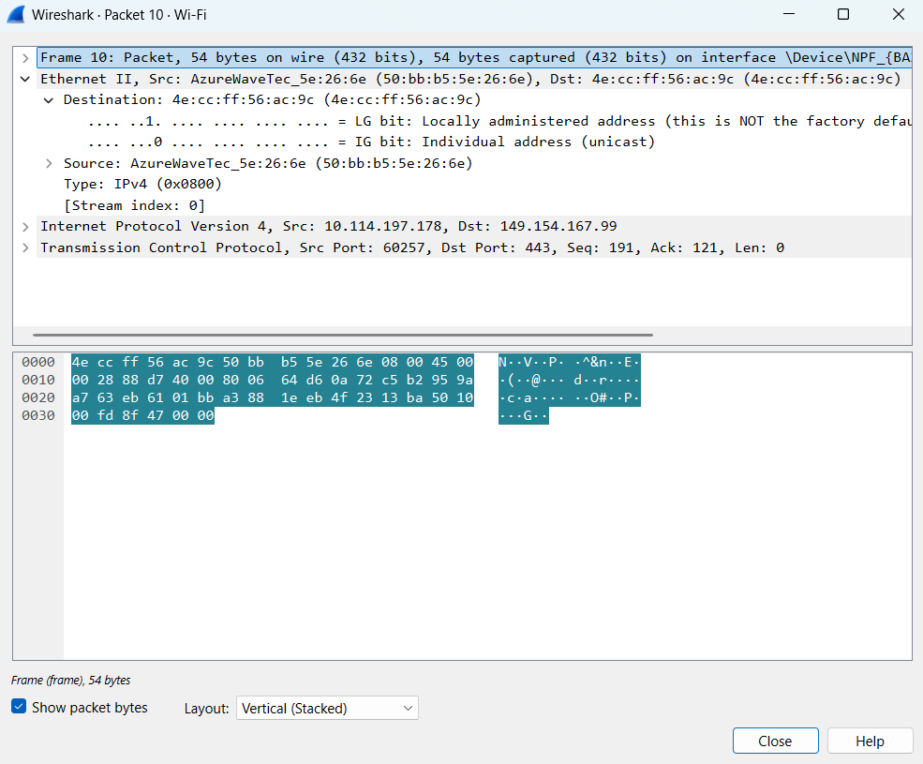

Ethernet:

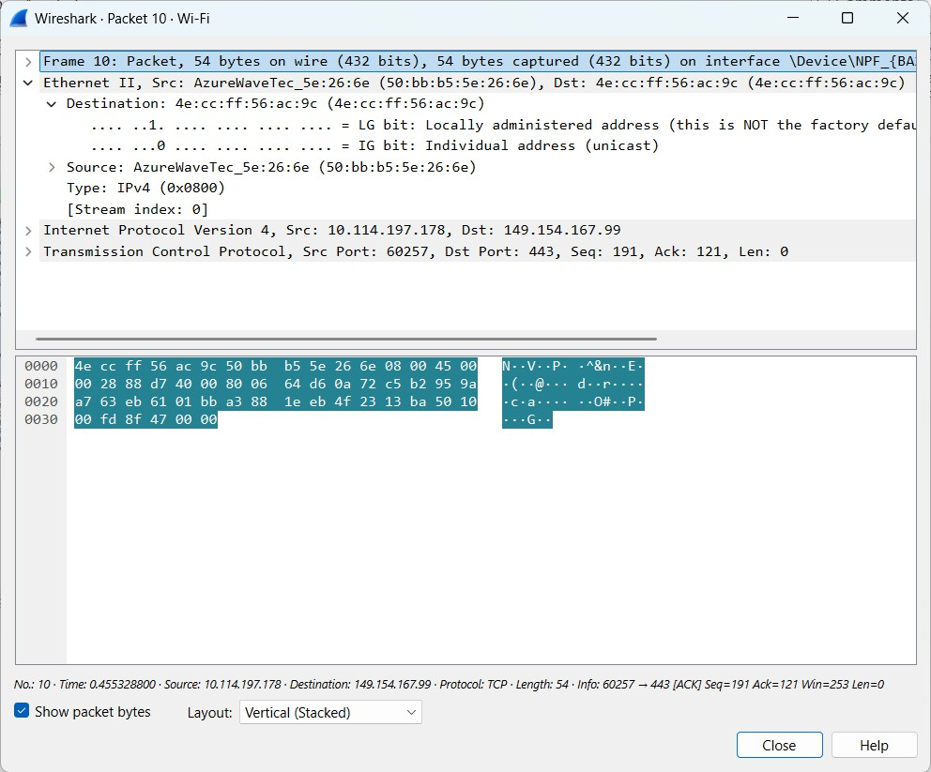
- Frame: 54 bytes
- Ethernet II: present
- IPv4: present
- TCP: present
- Source IP: 10.114.197.178
- Destination IP: 149.154.167.99
- Source port: 60257
- Destination port: 443

Udp:
- Frame:

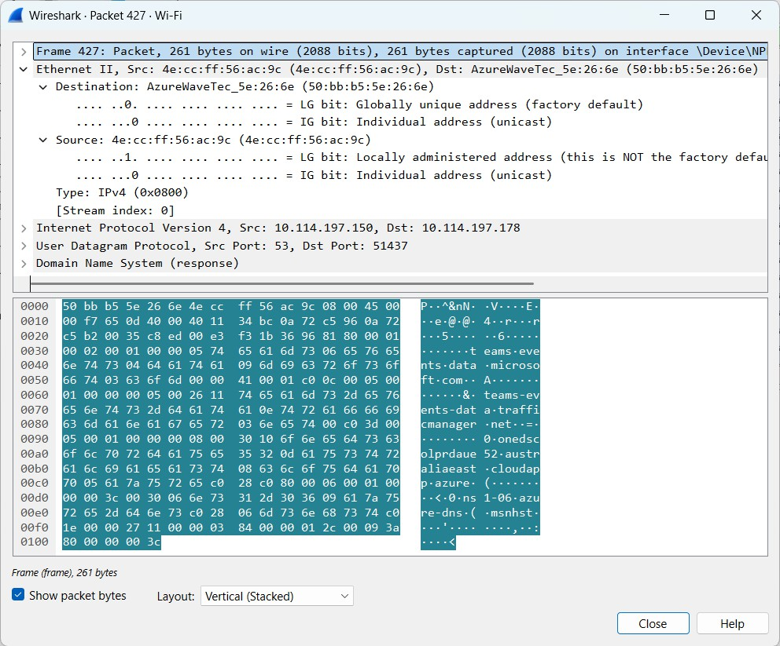

Ethernet:

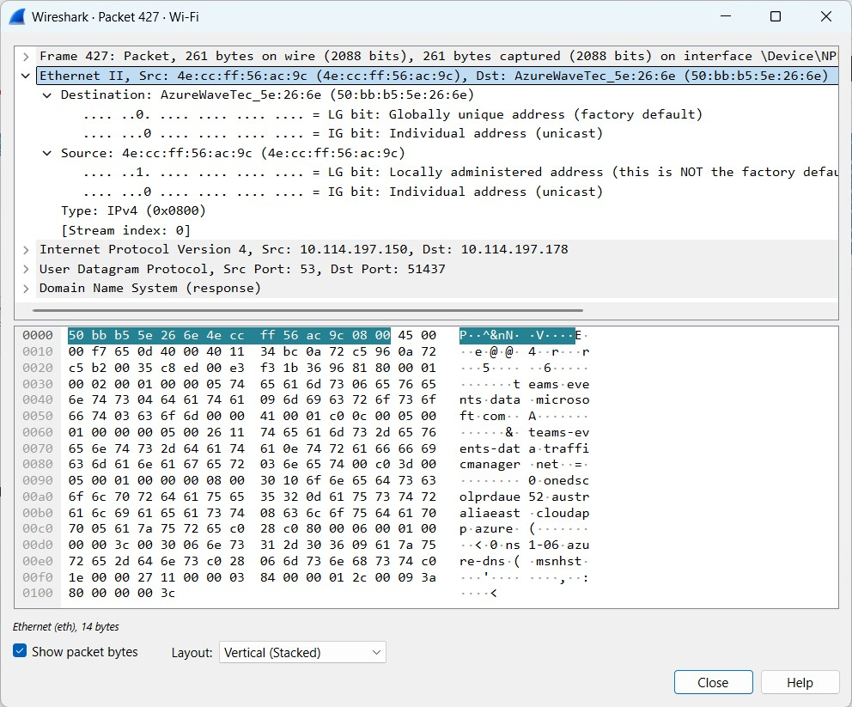
  - Frame: 261 bytes
  - Ethernet II: Present
  - IPv4: Present
  - UDP: Present
  - Source IP: 10.114.197.150
  - Destination IP: 10.114.197.178
  - Source port: 53
  - Destination port: 51437 Step-6:
Header Overhead = Ethernet + IPv4 + UDP
= 14 + 20 + 8

Payload Efficiency:
219/261 * 100 = 83.91%

Parameter | TCP packet | UDP packet
Frame length | 54 | 261
Ethernet Header Length | 14 | 14
IP Header Length | 20 | 20
Transport Header Length | 20 | 8
IP Total Length | 40 | 247
Transport Segment Length | 20 | 227
Payload Length | 0 | 219

Questions:
- What is encapsulation?
Adding headers to data before sending it over a network is called Encapsulation.
- What is the purpose of the Ethernet header?
It contains the source and destination MAC addresses.
- What information is stored in the IP header? Source IP, destination IP and packet length.
- What is the difference between TCP and UDP headers?
TCP supports reliable data delivery, while UDP is simpler and faster.
- Why does each protocol add a header?
To provide the information needed to send and receive data.
- What is packet overhead?
Extra data added to a packet apart from the actual data.
- How does header overhead affect network efficiency?
More overhead means less space for actual data, reducing efficiency.

